# Lab5

# Exercise-1

Write the HTML code which use of:

* The italics tag
* The Center tag
* The paragraph tag
* The Break tag
* The Font tag and its attributes

Code

<!DOCTYPE html>

<html lang="en">

<head>

<meta charset="UTF-8">

<meta name="viewport" content="width=device-width, initial-scale=1.0">

<title>Exercise 1</title>

</head>

<body>

<center>

<p><font color="blue"><i>Beware of password hackers and crackers!</i></font></p>

</center>

<p>

The threat of hackers and crackers is for real, and is alike for everyone. If the security breach at the Babha Atomic Research Center last year by the hacker group milworm didn’t convince you of their capabilities, then consider this: James Davis aka jdavis_a, a resident of <font color="green"><i>www.geocities.com/SiliconValley/Bit/2483</i></font> homestead community on the Internet, might just be reading your e-mail in your mailbox right now, or using your account for some benign Internet surfing, or exchanging it with someone else on the Net for more such accounts!

<br>

Surprised? Or scared?

</p>

<p>

<font color="red"><i>Formula:</i></font><br>

<font color="purple">(a-b)<sup>2</sup> = a<sup>2</sup> - 2ab + b<sup>2</sup></font><br>

<font color="orange">C<sub>6</sub>H<sub>12</sub>O<sub>6</sub> + 6O<sub>2</sub></font>

</p>

<p>

Whatever it is, <font size="3"><i>jdevis_4</i></font> claims in his home page <i>Free VSNL passwords</i> that he has got exactly <font color="brown">108</font> working passwords (and growing daily), <font color="brown">36</font> satyam, <font color="brown">31</font> MNTL, <font color="brown">11</font> WimiNet and <font color="brown">23</font> online passwords.

</p>

</body>

</html>

Output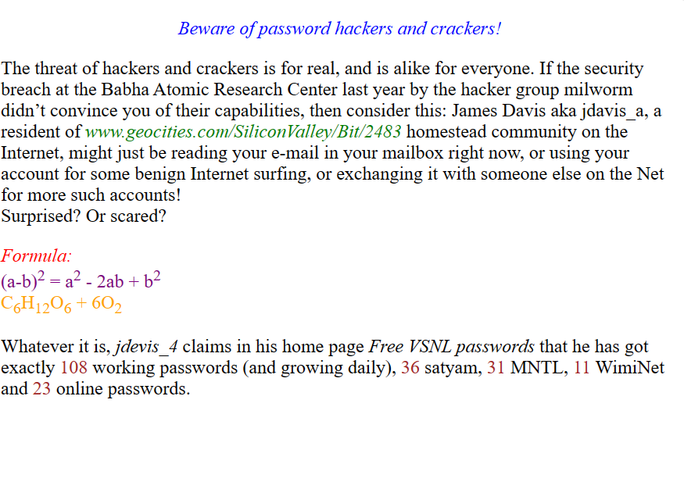

# Exercise-2

Looking at the screen given below write the HTML code making use of following tags

Unordered Lists

Ordered Lists

Definition Lists

Heading tag

Code

<!DOCTYPE html>

<html lang="en">

<head>

<meta charset="UTF-8">

<meta name="viewport" content="width=device-width, initial-scale=1.0">

<title>Lists and Headings Example</title>

</head>

<body>

<h1>Example on Unordered List</h1>

<ul>

<li>Sportstar</li>

<li>Business Week</li>

<li>Time</li>

</ul>

<h2>Example on Ordered List</h2>

<ol>

<li>Sportstar</li>

<li>Business Week</li>

<li>Time</li>

</ol>

<h3>Example on Definition List</h3>

<dl>

<dt>Sports Magazine</dt>

<dd>Sportstar</dd>

<dt>Business Magazine</dt>

<dd>Business Week</dd>

</dl>

</body>

</html>

Output

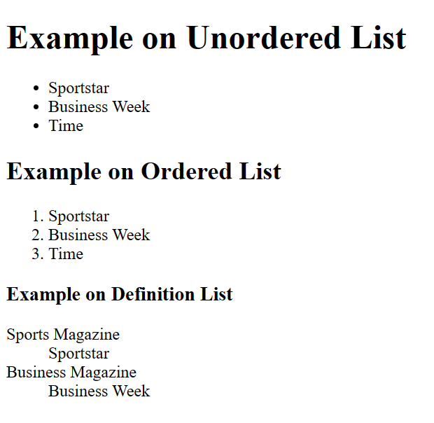

## *Exercise-3*

Design a **two** web page according to the following specifications.

Page 1 detail:

Use “landscape.jpg” image as page background and display the content on top of it. Text content should visible, background image should not affect the text content.

Page 2 detail:

Use “BLACK color” as background color and display text content on top of it using

“WHITE color”

Code

<!DOCTYPE html>

<html lang="en">

<head>

<meta charset="UTF-8">

<meta name="viewport" content="width=device-width, initial-scale=1.0">

<title>Page 2</title>

<style>

body {

margin: 0;

padding: 0;

background-color: black;

color: white;

font-family: Arial, sans-serif;

text-align: center;

}

.content {

padding: 50px;

}

</style>

</head>

<body>

<div class="content">

<h1>What is Web Design?</h1>

<p>Web design refers to the design of websites that are displayed on the internet. It usually refers to the user experience aspects of website development rather than software development. Web design used to be focused on designing websites for desktop browsers; however, since the mid-2010s, design for mobile and tablet browsers has become ever-increasingly important.</p>

</div>

</body>

</html>

Output

